**Growl Notifications Widgets**

# Table of Contents

Table of Contents 2

Manual Installation 3

Auto-Installation 3

## Manual Installation

1. Copy **com.temenos.widgets.edge.notifications** folder in your widgets folder (Ex: /{your project/templates })
2. Restart IDE.

## Auto-Installation

1. Run IDE.
2. Make sure the “**Switch Monitor on/off**” is checked.
3. Download/ Copy the widget (**com.temenos.widgets.edge.notifications.zip**) to monitored folder.

(**Tools** menu, **Options**, **Auto-install** tab and set in “**Download Location**” the folder where you copied the widgets.) No need to restart IDE.

# 

1. **Growl widget**

**Overview**

Growl is a notification widget and pop-up notification implementation based on bootstrap CSS framework.

Growl does not require bootstrap.js as a dependency.

1. You will have to insert a new display Item of **Growl** type in the **Presentation Editor**
2. Within **Widget Details**  tab you have to set up the widget settings.

* **Type** - Defines the style of the growl using bootstraps native alert styles .
* **Message** - The message that will be displayed within the growl notification.
* **Title** - The title that will be displayed within the growl notification.
* **Url** - If this value is set it will make the entire growl (except the close button) a clickable area. If the user clicks on this area it will take them to the url specified here.
* **Icon Type** - This is used to let the widget know if you are using an icon font for images or if you are using image.
* **Icon**  - This is the icon that will be displayed within the growl notification. This icon can either be a class (Font Icon) or an image url. Please keep in mind if you wish to use a image url that you must set Icon type to image in the options.
* **Allow dismiss** - If this is checked it will show the growl close button.
* **Mouse over** - If this is checked , when mouse is over growl it will pause the timer on the growl delay.
* **Delay** - If delay is set higher than 0 then the growl will auto-close after the delay period is up. Please keep in mind that delay uses milliseconds so 5000 is 5 seconds.
* **Timer** - This is the amount of milliseconds removed from the growl at every timer milliseconds. So to make that a little less confusing every 1000 milliseconds there will be 1000 milliseconds removed from the remaining time of the growl delay. If this is set higher then delay the growl will not be removed until timer has run out.
* **Animation enter** - This will control the animation used to bring the generate the growl on screen.
* **Animation exit** - This will control the animation used when the growl is removed from the screen.
* **Position** - This controls where if the growl will be placed at the top or bottom of your element.
* **Align** - This controls if the growl will be placed in the left, center or right side of the element.
* **Offset x** - This adds a padding on the x axis in pixels between the element and the growl creating a space between their edges.
* **Offset y** - This adds a padding on the y axis in pixels between the element and the growl creating a space between their edges.
* **Z-index -** This sets the css property z-index for the growl. You may have to raise this number if you have other elements overlaping the growl.
* **Spacing** - This adds a padding in pixels between growls with the same placement creating a space between their edges.

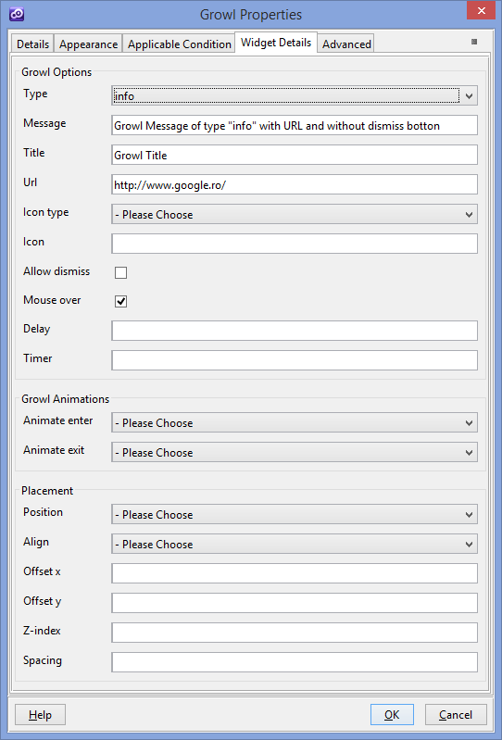

You could find more details on this website (<http://bootstrap-growl.remabledesigns.com/> )